# OPERATING SYSTEMS

ASSIGNMENT 1

EISHA TIR RAAZIA

17K-3730

SEC-C

INSTRUCTOR: MISS HASINA KHATOON

Q1:

 

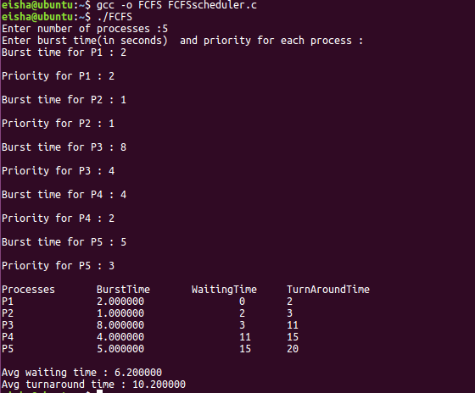

Figure FCFS

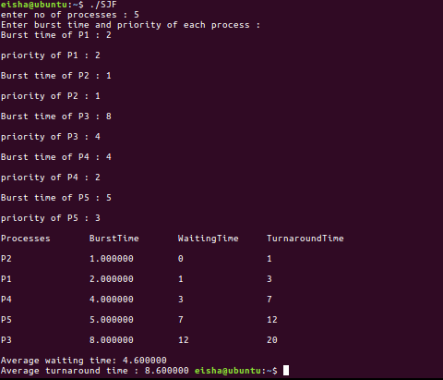

Figure SJF

1. Average turnaround time for FCFS : 10.2
2. Average turnaround time for SJF : 8.60
3. Waiting times

SJF: 4.600

FCFS: 6.200

1. SJF has minimum average time.

**Processes:**

Q1:



Q2:



**Shell scripting:**

**a)**



b)



c)



d) NO because bash does not have pointers but it has references to allow variables to be referenced indirectly.

e)



f)



g)





**All codes zip file:**

